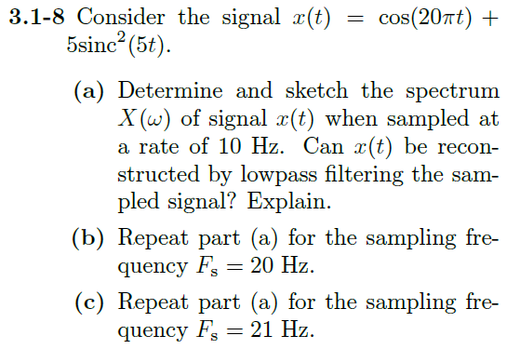

Using the Transform Handout, we know that:







Through linearity we can solve both these individually.

$$\cos\left(20πt\right)→ π\left(δ\left(w-20π\right)+δ\left(w+20π\right)\right)$$

$$5sinc^{2}\left(5t\right)→5\left(Λ\left(\frac{ω}{20π}\right)\right)$$

Using MATLAB,

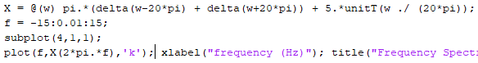

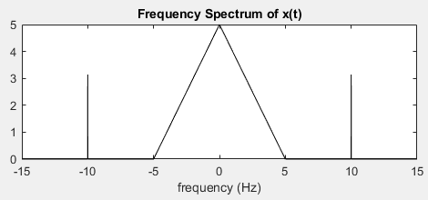

From class, we know that we can express sampling in the CT domain with “impulse sampling” (delta train). Delta trains in CT leads to delta trains in the frequency domain. When we scale this delta train, then do a Fourier transform we see that It leads to replications of our original X(w) depending on our sampling frequency (distance between deltas in train).

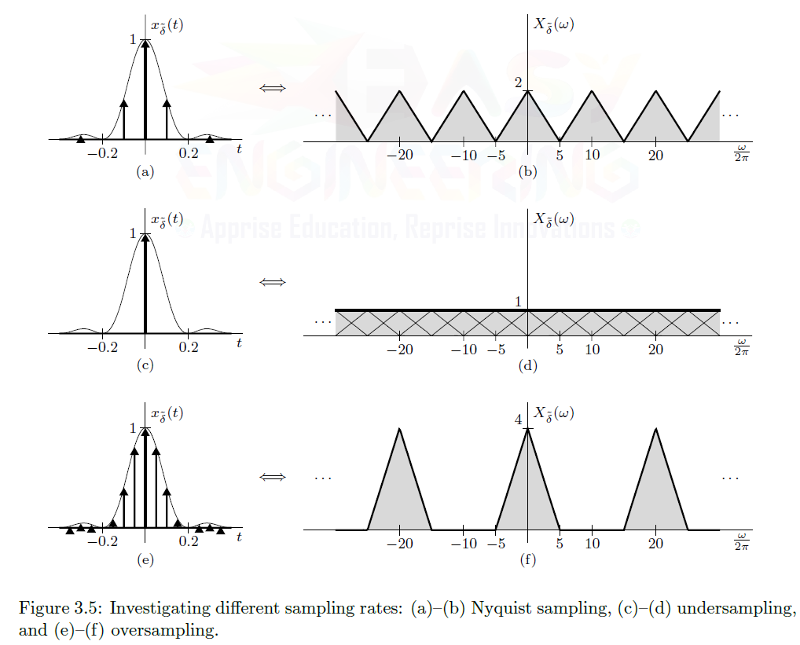

We can see that the spectra are just repeated in the frequency domain spaced by whatever frequency we are sampling at. If the spectra overlap, they add, which can cause problems as seen in figure 3.5c above.

Note for below MATLAB plots:

1. I use different colors. You may not be able to notice the color differentiation on black and white printing

2. I do not add the spectra where they overlap. I didn’t want to spend the time figuring out a way to have them add, so I used color instead to see if they overlap.

a) $10Hz→0.1s$ period between samples in time domain

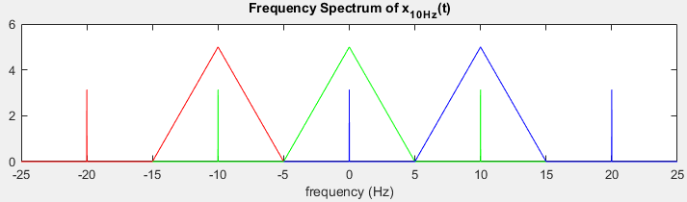

This cannot be low pass filtered. The impulse spectra from the red spectra (left) and blue spectra (right) intrude on the green spectra (center).

b) 20Hz 🡪0.05s period

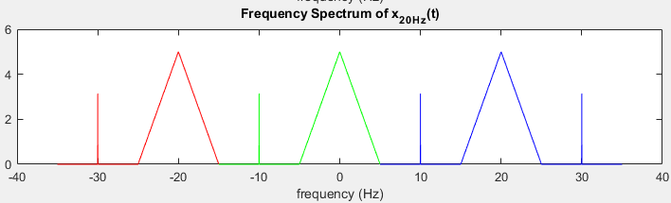

You cannot low pass filter this either. We can see that the red spectra (left) and green spectra (center) impulses and the green spectra (center) and the blue spectra (right) overlap at the edges.

c) 21Hz 🡪 0.0476190476190476s period

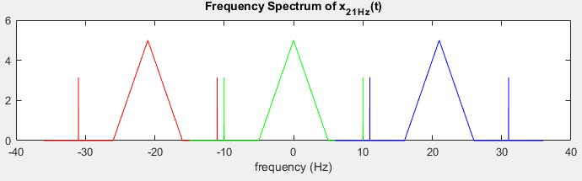

This could be reconstructed with a low pass filter. There is a gap between the red (left), green (center), and blue (right) spectra, so none of the spectra overlap. This makes sense because:

$$21Hz \left(F_{s}\right)>2*10Hz(\max{frequency component of x(t))}$$

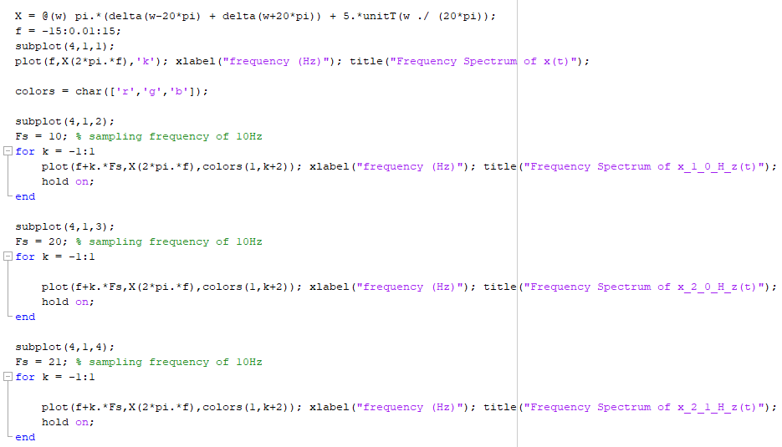

3.1-9) Refer to Fig. P3.1-9 for plots of the bandpass spectra *X*(*ω*) and *Y* (*ω*).

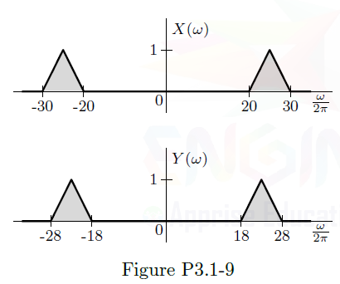

**(a)** The highest frequency in *X*(*ω*) is 30Hz. According to the Nyquist criterion, the minimum sampling

frequency needed to sample *x*(*t*) is 60Hz. Letting the sampling rate *F*s = 60 Hz, sketch the spectrum *X*˜*δ*(*ω*) of the

sampled signal *x*˜*δ*(*t*). Can you reconstruct *x*(*t*) from these samples? How?

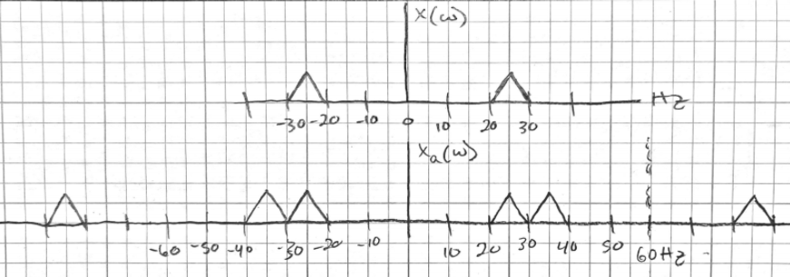

If you have an ideal LPF (transition band = 0Hz) that has a cutoff frequency of 30Hz, then you can reconstruct x(t). There is no realistic filter that can be used to reconstruct x(t)

**(b)** A certain student looks at *X*(*ω*) and concludes, since its bandwidth is only 10 Hz, that a sampling rate of 20 Hz is

adequate for sampling *x*(*t*). Using the sampling rate *F*s = 20 Hz, sketch the spectrum *X*˜*δ*(*ω*) of the sampled signal

*x*˜*δ*(*t*). Can she reconstruct *x*(*t*) from these samples? Explain.

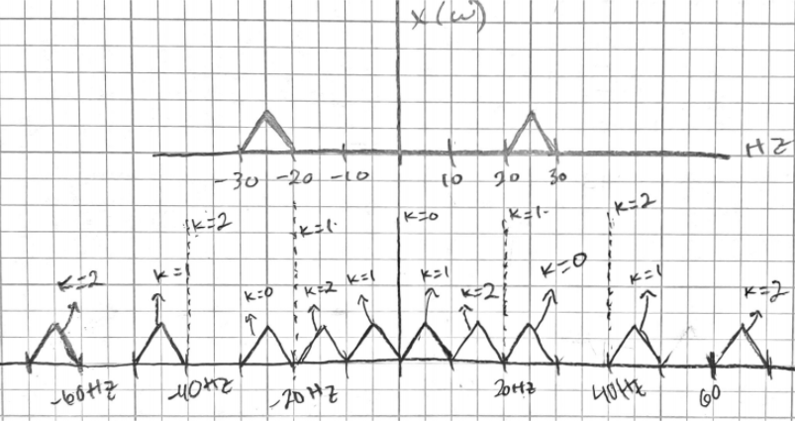

If you have an ideal Band pass filter (transition band = 0Hz) that has a start frequency of 20Hz and a stop frequency of 30Hz, then you can reconstruct x(t). There is no realistic filter that can be used to reconstruct x(t) because no real filters are ideal.

**(c)** The same student, using the same reasoning, looks at spectrum *Y* (*ω*) and again concludes that she can use a

sampling rate of 20 Hz. Setting *F*s = 20 Hz, sketch the spectrum *Y*˜*δ*(*ω*) of the sampled signal *y*˜*δ*(*t*). Can she reconstruct *y*(*t*) from these samples? Explain.

The first plot shows one replication drawn. The second plot shows 3 replications drawn.

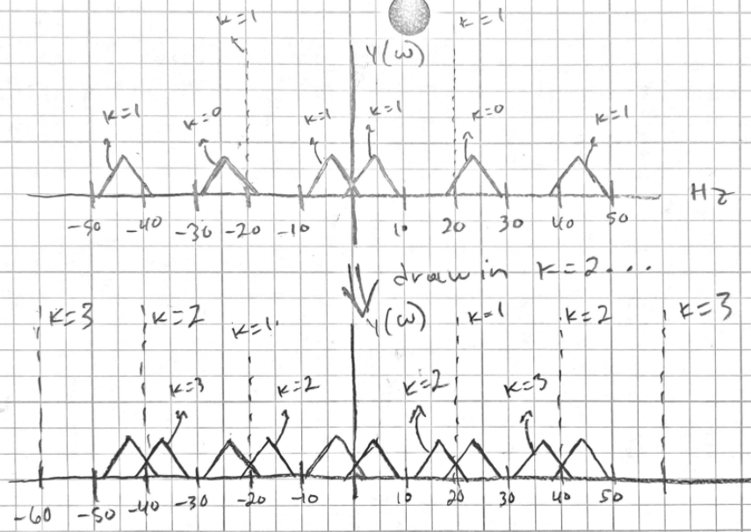

Because the ends from k = 2 overlap with the original spectra, there is no way to reconstruct the original signal after sampling at this rate. No LP, HP, BS, BP filters can restore the original y(t).